Astronomy Assessment and TPS Questions:
Path of the Sun

- For an observer in the continental U.S., which of the x’s (a – d) in the figure at right correctly shows the position of the top of the stick’s shadow at noon for different times of the year? Note that the positions of the Sun’s shadow at noon on the solstices are shown.
  - only position a
  - only position b
  - only position c
  - only position d
  - more than one of the positions (a-d) is possible

- Which of the following statements is true about the location of the Sun at sunset during the middle of winter?
- It will be near the horizon, north of west.
- It will be near the horizon, north of east.
- It will be near the horizon, south of west.
- It will be near the horizon, south of east.
- None of the above is correct.

- Which of the following statements is true about the location of the Sun at sunrise during the middle of summer?
  - It will be near the horizon, north of west.
  - It will be near the horizon, north of east.
  - It will be near the horizon, south of west.
  - It will be near the horizon, south of east.
  - None of the above.

- For an observer in the continental U.S., which of the three shadow plots, shown at right, correctly depicts the Sun’s motion for one day?
x
x
x
x
x
x

x
x
x
x
x
x
x
x
NORTH
SOUTH
WEST
Shadow
plot A
Shadow
plot C
x

x
x
x
x

x
x
x
Shadow
plot B
EAST
- Shadow plot A
- Shadow plot B
- Shadow plot C
- More than one of the plots is possible, on different days of the year.
- None of the plots are possible.

- Which of the following statements is most correct for the day of the year when a flagpole casts its longest shadow at noon?
- It is the day of the winter solstice.
- The Sun will rise directly in the East and will set directly in the West on that day.
- At noon on that day, the Sun will be the highest in the sky that it appears all year.
- The Sun will rise north of East on that day.

- If you are located in the continental U.S. on the first day of October, how will the position of the Sun at noon be different two weeks later?
- It will have moved toward the North.
- It will have moved to a position higher in the sky.
- It will stay in the same position.
- It will have moved to a position closer to the horizon.
- It will have moved toward the west.

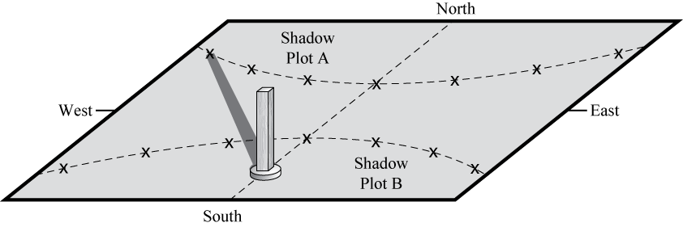
- Which shadow plot (A or B) most closely corresponds to the Sun’s path through the sky during the summer?
- Shadow plot A
- Shadow plot B

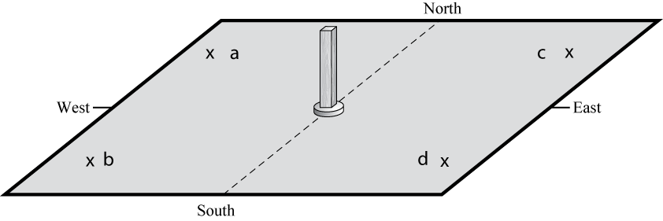
- Which “X” could represent the position of the end of the stick’s shadow made shortly before sunset during the summer?
  - a
  - b
  - c
  - d
  - None of the above

- At Noon on the day of the Summer Solstice, how will your shadow appear:
  - short and pointing to the south.
  - short and pointing to the north.
  - long and pointing to the north.
  - long and pointing to the south.
  - at noon on this day you will not cast a shadow.

- At Noon on the day when the Sun goes highest in the sky for the entire year, how will your shadow appear:
- short and pointing to the south.
- short and pointing to the north.
- long and pointing to the north.
- long and pointing to the south.
- at noon on this day you will not cast a shadow.

- Which of the following locations experiences the least amount of change in sunlight over the course of a year?
- north pole,
- south pole,
- equator
- They all experience the same amount of change in sunlight over a year

- The Sun appears to rise and set in our sky because _______________, and you are one year older each time _____________.
- Earth rotates on its axis; Earth completes one orbit of the Sun
- the Sun moves across the orbit of Earth; the Sun completes one rotation on its axis
- Earth’s rotational axis is tilted, Earth completes one rotation on its axis
- the Sun rotates on its axis; Earth completes one orbit of the Sun
- Earth rotates on its axis; the Sun completes one rotation on its axis

